Economics: Canada in the Global Environment, 7e (Parkin)
Chapter 2 The Economic Problem

2.1 Production Possibilities and Opportunity Cost

1) The production possibilities frontier
A) is the boundary between attainable and unattainable levels of production.
B) is the boundary between what we want to consume and what we want to produce.
C) shows how production increases as prices rise.
D) shows prices at which production is possible and impossible.
E) illustrates why there need not be any scarcity in the world.
Answer: A
Diff: 1
Topic: Production Possibilities and Opportunity Cost

2) Which one of the following concepts is not illustrated by a production possibilities frontier?
A) scarcity
B) monetary exchange
C) opportunity cost
D) attainable and unattainable points
E) the tradeoff between producing one good versus another
Answer: B
Diff: 2
Topic: Production Possibilities and Opportunity Cost

3) A point inside a production possibilities frontier
A) indicates some unused or misallocated resources.
B) is unattainable.
C) is preferred to a point on the production possibilities frontier.
D) indicates a point of production efficiency.
E) illustrates the idea of opportunity cost.
Answer: A
Diff: 1
Topic: Production Possibilities and Opportunity Cost

4) Which one of the following concepts is illustrated by a production possibilities frontier?
A) profit
B) consumption
C) investment
D) monetary exchange
E) the tradeoff between producing one good versus another
Answer: E
Diff: 1
Topic: Production Possibilities and Opportunity Cost
5) If Sam is producing at a point inside his production possibilities frontier, then he
A) can increase production of both goods with zero opportunity cost.
B) is fully using all his resources and allocating his resources to their best use.
C) must be doing the best he can with limited resources.
D) is unaffected by costs and technology.
E) has a high opportunity cost of moving from this point.
Answer: A
Diff: 2
Topic: Production Possibilities and Opportunity Cost

6) If Sam is producing at a point on his production possibilities frontier, then he
A) cannot produce any more of either good.
B) is unaffected by costs and technology.
C) can produce more of both goods.
D) is not subject to scarcity.
E) can increase the production of one good only by decreasing the production of the other.
Answer: E
Diff: 2
Topic: Production Possibilities and Opportunity Cost

Use the figure below to answer the following questions.

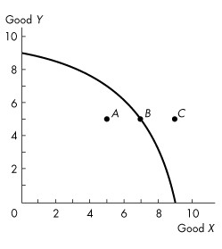
Figure 2.1.1

7) Refer to the production possibilities frontier in Figure 2.1.1. Which one of the following is true about point A?
A) It is unattainable.
B) While no more of good Y can be produced, more of good X can be produced.
C) It is preferred to point B.
D) Resources are either unused or misallocated or both.
E) It is attainable only if the amount of capital goods is increased.
Answer: D
Diff: 1
Topic: Production Possibilities and Opportunity Cost
8) Complete the following sentence. In Figure 2.1.1,
A) movement from A to B would require a technological advance.
B) point B is a point of production efficiency.
C) some resources must be unused at point C.
D) the concept of decreasing opportunity cost is illustrated.
E) movement from C to B would require a technological improvement.
Answer: B
Diff: 2
Topic: Production Possibilities and Opportunity Cost

9) Refer to the production possibilities frontier in Figure 2.1.1, which one of the following is true about point C?
A) It is attainable only if we consume more of good X.
B) It is unattainable.
C) It is attainable only if we consume less of good Y.
D) It is attainable only if we consume less of good X.
E) It is attainable only if we consume more of good Y.
Answer: B
Diff: 2
Topic: Production Possibilities and Opportunity Cost

10) If Harold can increase production of good X without decreasing production of any other good, then Harold
A) is producing on his production possibilities frontier.
B) is producing outside his production possibilities frontier.
C) is producing inside his production possibilities frontier.
D) must have a linear production possibilities frontier.
E) must prefer good X to any other good.
Answer: C
Diff: 2
Topic: Production Possibilities and Opportunity Cost
Source: Study Guide

11) If Harold must decrease production of some other good to increase production of good X, then Harold
A) is producing on his production possibilities frontier.
B) is producing outside his production possibilities frontier.
C) is producing inside his production possibilities frontier.
D) must prefer good X to any other good.
E) has too few capital goods.
Answer: A
Topic: Production Possibilities and Opportunity Cost
12) A situation in which resources are either unused or misallocated or both is represented in a production possibilities frontier diagram by
A) any point on either the horizontal or the vertical axis.
B) a point above or to the right of the production possibilities frontier.
C) a point outside the production possibilities frontier.
D) a point inside the production possibilities frontier.
E) a point on or inside the production possibilities frontier.
Answer: D
Diff: 1
Topic: Production Possibilities and Opportunity Cost

13) A production possibilities frontier is negatively sloped because
A) more goods are purchased as price falls.
B) of opportunity cost.
C) some resources are unused.
D) there is not enough capital in the economy.
E) of increasing consumption.
Answer: B
Diff: 2
Topic: Production Possibilities and Opportunity Cost

14) Ted chooses to study for his economics exam instead of going to the concert. The concert he will miss is Ted's ________ of studying for the exam.
A) monetary cost
B) absolute cost
C) opportunity cost
D) discretionary cost
E) comparative cost
Answer: C
Diff: 1
Topic: Production Possibilities and Opportunity Cost

15) Opportunity cost of an action is
A) the best choice that can be made.
B) the highest-valued alternative forgone.
C) the money cost.
D) the comparative cost.
E) the absolute cost.
Answer: B
Diff: 1
Topic: Production Possibilities and Opportunity Cost
16) The concept of opportunity cost
A) is measured by the amount of the money costs of an activity.
B) explains that goods are swapped for other goods.
C) implies that when a person is more efficient in the production of one good, he should produce that good and exchange it for some good that he is relatively less efficient at producing.
D) implies that a double coincidence of wants must be present for exchange to take place.
E) implies that because productive resources are scarce, we must give up some of one good to acquire more of another.
Answer: E
Diff: 2
Topic: Production Possibilities and Opportunity Cost

17) On a graph of a production possibilities frontier, opportunity cost is represented by
A) a point on the horizontal axis.
B) a point on the vertical axis.
C) a ray through the origin.
D) the slope of the production possibilities frontier.
E) the x-axis intercept.
Answer: D
Diff: 2
Topic: Production Possibilities and Opportunity Cost

18) Production efficiency is achieved when
A) the production possibilities frontier shifts outward at an even pace.
B) there are no more tradeoffs.
C) all resources are equally productive in all activities.
D) resources are not equally productive in all activities.
E) we produce goods and services at the lowest possible cost.
Answer: E
Diff: 2
Topic: Production Possibilities and Opportunity Cost

19) A tradeoff exists when
A) we move from a point within the production possibilities frontier (PPF) to a point on the PPF.
B) we move from a point on the PPF to a point within the PPF.
C) the PPF shifts outward.
D) we move along the PPF.
E) the PPF shifts towards the origin.
Answer: D
Diff: 2
Topic: Production Possibilities and Opportunity Cost
20) Which of the following quotations best illustrates a tradeoff?
A) "If the firm reorganized its production process, it could produce more widgets and more gadgets."
B) "The firm should sell more gadgets, even if it means less widget sales."
C) "The more and more gadgets the firm produces, the bigger the fall in widget production."
D) "If the firm invests more in capital equipment, it can expand sales next year."
E) "The firm has been able to lower costs due to its extensive experience in building widgets."
Answer: C
Diff: 2
Topic: Production Possibilities and Opportunity Cost

21) A medical clinic has 10 workers. Each worker can produce a maximum of either 2 units of medical services or 5 units of secretarial services a day. The production possibilities frontier of this firm would show
A) increasing opportunity cost.
B) decreasing opportunity cost.
C) constant opportunity cost.
D) zero opportunity cost.
E) infinite opportunity cost.
Answer: C
Diff: 2
Topic: Production Possibilities and Opportunity Cost

22) A medical clinic has 10 workers. Each worker can produce a maximum of either 2 units of medical services or 5 units of secretarial services a day. The opportunity cost of one more unit of medical services is
A) 2 units of secretarial services.
B) 5 units of secretarial services.
C) 0.4 units of secretarial services.
D) 2.5 units of secretarial services
E) dependent on the level of services.
Answer: D
Diff: 2
Topic: Production Possibilities and Opportunity Cost

23) A medical clinic has 10 workers. Each worker can produce a maximum of either 2 units of medical services or 5 units of secretarial services a day. One day, the firm decides it would like to produce 10 units of medical services and 30 units of secretarial services. This output level is
A) efficient.
B) unattainable.
C) inefficient.
D) costless.
E) is attainable if the firm reduces the number of its workers.
Answer: B
Diff: 2
Topic: Production Possibilities and Opportunity Cost
24) A medical clinic has 10 workers. Each worker can produce a maximum of either 2 units of medical services or 5 units of secretarial services a day. One day, the firm decides it would like to produce 16 units of medical services and 5 units of secretarial services. This output level is
A) efficient.
B) unattainable.
C) inefficient.
D) costless.
E) attainable and efficient.
Answer: C
Diff: 2
Topic: Production Possibilities and Opportunity Cost

25) The bowed-out (concave) shape of a production possibilities frontier
A) is due to the equal usefulness of resources in all activities.
B) is due to capital accumulation.
C) is due to technological change.
D) reflects the existence of increasing opportunity cost.
E) reflects the existence of decreasing opportunity cost.
Answer: D
Diff: 2
Topic: Production Possibilities and Opportunity Cost
Source: Study Guide

26) If opportunity costs are increasing, then the production possibilities frontier
A) will be bowed out and have a positive slope.
B) will be positively sloped.
C) will be linear and have a negative slope.
D) will be bowed out and have a negative slope.
E) reflects the fact that available resources are equally useful in all production activities.
Answer: D
Diff: 1
Topic: Production Possibilities and Opportunity Cost

27) The fact that resources are not equally productive in all activities
A) implies that a production possibilities frontier will be bowed outward.
B) implies that gains from specialization and trade are unlikely.
C) follows from the law of demand.
D) implies a linear production possibilities frontier.
E) implies that an economy should not produce certain goods.
Answer: A
Diff: 2
Topic: Production Possibilities and Opportunity Cost
28) If additional units of any good could be produced at a constant opportunity cost, the production possibilities frontier would be
A) bowed inward.
B) bowed outward.
C) positively sloped.
D) negatively sloped.
E) linear.
Answer: E
Diff: 2
Topic: Production Possibilities and Opportunity Cost

29) The existence of increasing opportunity cost
A) explains why specialization is frequently useful.
B) explains why resources are scarce.
C) explains the bowed-out shape of the production possibilities frontier.
D) follows from the existence of property rights.
E) explains why some societies produce inside their production possibilities frontier.
Answer: C
Diff: 2
Topic: Production Possibilities and Opportunity Cost
Use the figure below to answer the following questions.

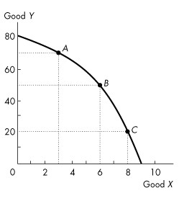
Figure 2.1.2

30) Refer to the production possibilities frontier in Figure 2.1.2. If 6 units of X are currently being produced, then
A) 40 units of Y cannot be produced unless production of X is decreased.
B) 40 units of Y cannot be produced unless production of X is increased.
C) 60 units of Y can be produced with some resources not fully used.
D) 50 units of Y must be produced, regardless of resource utilization.
E) 50 units of Y can be produced if all resources are used and assigned to the task for which they are the best match.
Answer: E
Diff: 1
Topic: Production Possibilities and Opportunity Cost

31) Refer to the production possibilities frontier in Figure 2.1.2. Suppose that 50 units of Y are currently being produced. Then
A) 7 units of X are being produced.
B) 6 units of X can be produced if all resources are used and assigned to the task for which they are the best match.
C) 9 units of X can be produced if all resources are used and assigned to the task for which they are the best match.
D) resources are not being fully utilized.
E) 6 units of X are being produced.
Answer: B
Diff: 1
Topic: Production Possibilities and Opportunity Cost
32) Refer to the production possibilities frontier in Figure 2.1.2. At point A, the opportunity cost of producing 3 more units of X
A) is 30 units of Y.
B) is 3 units of X.
C) is 20 units of Y.
D) is 10 units of Y.
E) cannot be determined from the diagram.
Answer: C
Diff: 2
Topic: Production Possibilities and Opportunity Cost

33) Refer to the production possibilities frontier in Figure 2.1.2. At point A, the opportunity cost of increasing production of Y to 80 units is
A) 10 units of Y.
B) 80 units of Y.
C) 2 units of X.
D) 3 units of X.
E) 1 unit of X.
Answer: D
Diff: 2
Topic: Production Possibilities and Opportunity Cost

34) Refer to the production possibilities frontier in Figure 2.1.2. At point C, the opportunity cost of producing one more unit of X is
A) 1 unit of Y.
B) 1 unit of X.
C) 8 units of X.
D) 20 units of X.
E) 20 units of Y.
Answer: E
Diff: 2
Topic: Production Possibilities and Opportunity Cost

35) Refer to the production possibilities frontier in Figure 2.1.2. At point C, what is the opportunity cost of increasing the production of Y from 20 to 50 units?
A) 6 units of X.
B) 2 units of X.
C) 8 units of X.
D) 20 units of Y.
E) 30 units of Y.
Answer: B
Diff: 2
Topic: Production Possibilities and Opportunity Cost
36) Consider the production possibilities frontier in Figure 2.1.2, and assume that everything that is produced is also consumed. Which of the following statements is false?
A) Resources are not equally useful in all activities.
B) Points inside the frontier indicate unused or misallocated resources.
C) Starting at point A, an increase in the production of Y will shift the frontier outward.
D) The opportunity cost of producing Y increases as production of Y increases.
E) The opportunity cost of producing X increases as production of X increases.
Answer: C
Diff: 2
Topic: Production Possibilities and Opportunity Cost

37) As we increase the production of X, we find we must give up larger and larger amounts of Y per unit of X. Select the best statement.
A) This illustrates increasing opportunity cost.
B) As a result, we should not specialize in the production of X.
C) The production possibilities frontier for X and Y is a straight line.
D) Good Y will be more highly regarded by consumers than good X.
E) We must be inside the production possibilities frontier.
Answer: A
Diff: 2
Topic: Production Possibilities and Opportunity Cost

Use the figure below to answer the following questions.

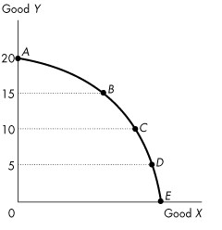
Figure 2.1.3

38) Figure 2.1.3 illustrates Mary's production possibilities frontier. If Mary wants to move from point B to point C,
A) it will be necessary to improve technology.
B) it will be necessary to increase the accumulation of capital.
C) it will be necessary to give up some of good X to obtain more of good Y.
D) it will be necessary to give up some of good Y to obtain more of good X.
E) she can accomplish this without any opportunity cost.
Answer: D
Diff: 1
Topic: Production Possibilities and Opportunity Cost
39) Figure 2.1.3 illustrates Mary's production possibilities frontier. If Mary wants to move from point D to point C,
A) it will be necessary to improve technology.
B) it will be necessary to increase the accumulation of capital.
C) it will be necessary to give up some of good X to obtain more of good Y.
D) it will be necessary to give up some of good Y to obtain more of good X.
E) she can accomplish this without any opportunity cost.
Answer: C
Diff: 1
Topic: Production Possibilities and Opportunity Cost

40) Refer to the production possibilities frontier in Figure 2.1.3. The opportunity cost of moving from C to B will be
A) greater than moving from D to C but less than moving from B to A.
B) less than moving from D to C but greater than moving from B to A.
C) the same as moving from D to C or moving from B to A.
D) greater than moving either from D to C or from B to A.
E) neither greater than moving from D to C nor moving from B to A.
Answer: A
Diff: 2
Topic: Production Possibilities and Opportunity Cost

41) Refer to the production possibilities frontier in Figure 2.1.3. Which one of the following movements requires the largest opportunity cost of increased Y?
A) E to D
B) D to C
C) C to B
D) B to A
E) The opportunity cost is the same in each case.
Answer: D
Diff: 2
Topic: Production Possibilities and Opportunity Cost

42) Refer to the production possibilities frontier in Figure 2.1.3. Which one of the following movements requires the largest opportunity cost of increased X?
A) A to B
B) B to C
C) C to D
D) D to E
E) The opportunity cost is the same in each case.
Answer: D
Diff: 2
Topic: Production Possibilities and Opportunity Cost
43) Refer to the production possibilities frontier in Figure 2.1.3. The fact that less of X must be given up when moving from D to C than when moving from B to A indicates
A) decreasing opportunity cost.
B) increasing opportunity cost.
C) comparative advantage in the production of X.
D) the consequences of technological improvement.
E) unemployed resources at D.
Answer: B
Diff: 2
Topic: Production Possibilities and Opportunity Cost

Use the table below to answer the following questions.

Table 2.1.1
The following table gives points on the production possibilities frontier for goods X and Y.

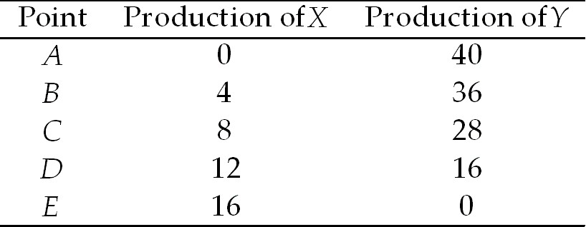

44) Refer to Table 2.1.1. What does point C mean?
A) If 8 units of X are produced, then at least 28 units of Y can be produced.
B) If 8 units of X are produced, then at most 28 units of Y can be produced.
C) If 28 units of Y are produced, then more than 8 units of X can be produced.
D) If 8 units of X are produced, then only 36 units of Y can be produced.
E) There is unemployment at this point.
Answer: B
Diff: 1
Topic: Production Possibilities and Opportunity Cost

45) Refer to Table 2.1.1. The opportunity cost of increasing the production of X from 8 to 12 units is
A) 4 units of X.
B) 4 units of Y.
C) 8 units of Y.
D) 12 units of Y.
E) 16 units of Y.
Answer: D
Diff: 2
Topic: Production Possibilities and Opportunity Cost
46) Refer to Table 2.1.1. The opportunity cost of increasing the production of Y from 16 to 36 units is
A) 4 units of X.
B) 8 units of X.
C) 12 units of X.
D) 16 units of X.
E) 20 units of Y.
Answer: B
Diff: 2
Topic: Production Possibilities and Opportunity Cost

47) The economy illustrated by the data in Table 2.1.1 exhibits
A) decreasing opportunity cost.
B) constant opportunity cost in the production of X.
C) constant opportunity cost in the production of Y.
D) increasing opportunity cost.
E) initially increasing, then decreasing opportunity cost.
Answer: D
Diff: 2
Topic: Production Possibilities and Opportunity Cost

48) From the data in Table 2.1.1, the production of 7 units of X and 28 units of Y is
A) unattainable.
B) attainable but leaves some resources unused or misallocated or both.
C) on the PPF between points C and D.
D) on the PPF between points B and C.
E) outside the PPF.
Answer: B
Diff: 2
Topic: Production Possibilities and Opportunity Cost

49) Refer to Table 2.1.1. As we increase the production of X,
A) the amount of Y that is given up for each additional unit of X decreases.
B) the output of Y increases.
C) the opportunity cost of each additional unit of X increases.
D) unemployment increases.
E) the amount of X increases at an increasing rate.
Answer: C
Diff: 1
Topic: Production Possibilities and Opportunity Cost

50) From the data in Table 2.1.1 we can infer that
A) the economy illustrated has a comparative advantage in the production of Y.
B) the economy illustrated has a comparative advantage in the production of X.
C) the opportunity cost of producing an additional unit of Y increases as the production of Y increases.
D) the opportunity cost of producing an additional unit of Y decreases as the production of Y increases.
E) none of the above.
Answer: C
Diff: 2
Topic: Production Possibilities and Opportunity Cost
51) The diagram of the production possibilities frontier corresponding to the data in Table 2.1.1 would be
A) negatively sloped and linear.
B) negatively sloped and bowed inward.
C) negatively sloped and bowed outward.
D) positively sloped for X and negatively sloped for Y.
E) a horizontal line.
Answer: C
Diff: 2
Topic: Production Possibilities and Opportunity Cost

52) From the data in Table 2.1.1, the production of 10 units of X and 28 units of Y is
A) unattainable.
B) attainable but leaves some resources misallocated.
C) on the production possibilities frontier between points C and D.
D) inside the PPF.
E) possible if we reduce the amount of capital goods.
Answer: A
Diff: 2
Topic: Production Possibilities and Opportunity Cost

Use the table below to answer the following questions.

Table 2.1.2
Production Possibilities

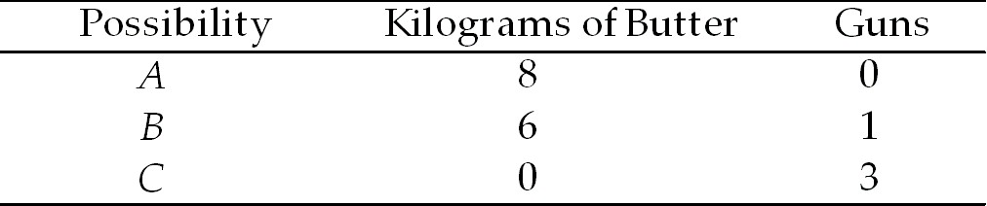

53) Refer to Table 2.1.2. In moving from combination B to combination C, the opportunity cost of producing one additional unit of guns is
A) 2 kilograms of butter.
B) 1/2 kilogram of butter.
C) 6 kilograms of butter.
D) 1/6 kilogram of butter.
E) 3 kilograms of butter.
Answer: E
Diff: 3
Topic: Production Possibilities and Opportunity Cost

54) Refer to Table 2.1.2. According to this production possibilities frontier,
A) a combination of 6 kilograms of butter and 1 gun leaves some resources unused.
B) a combination of 0 butter and 4 guns is attainable.
C) resources are equally useful in all activities.
D) the opportunity cost of producing guns increases as more guns are produced.
E) the opportunity cost of producing guns decreases as more guns are produced.
Answer: D
Diff: 1
Topic: Production Possibilities and Opportunity Cost
Use the table below to answer the following questions.

Table 2.1.3
Production possibilities for a society that produces only two
goods – hockey sticks and maple leaves.

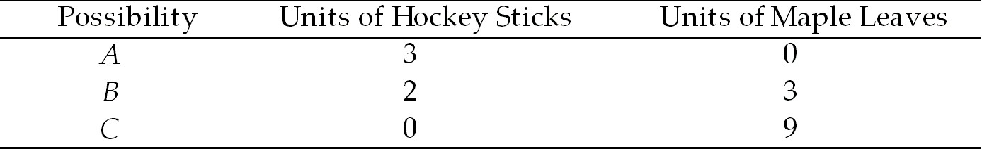

55) Refer to Table 2.1.3. In moving from combination C to combination B, the opportunity cost of producing one additional hockey stick is
A) 2 maple leaves.
B) 1/2 maple leaves.
C) 6 maple leaves.
D) 1/6 maple leaves.
E) 3 maple leaves.
Answer: E
Diff: 2
Topic: Production Possibilities and Opportunity Cost
Source: Study Guide

56) Refer to Table 2.1.3. According to this production possibilities frontier
A) resources are equally productive in all activities.
B) a combination of 3 hockey sticks and 9 maple leaves is attainable.
C) a combination of 3 hockey sticks and 9 maple leaves would not employ all resources.
D) the opportunity cost of producing hockey sticks increases as more hockey sticks are produced.
E) the opportunity cost of producing hockey sticks decreases as more hockey sticks are produced.
Answer: A
Diff: 1
Topic: Production Possibilities and Opportunity Cost
Source: Study Guide
Use the table below to answer the following question.

Table 2.1.4
Consider the following production possibilities for A. Student for the typical week:

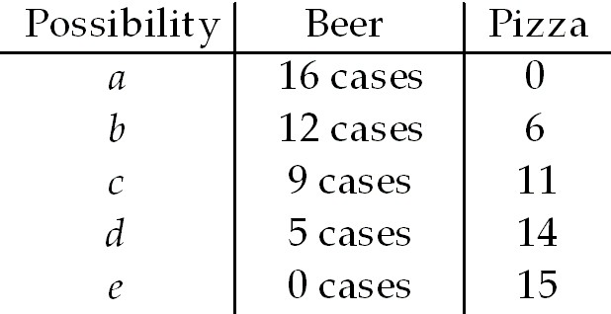

57) Refer to Table 2.1.4. Complete the following sentence. The production possibility frontier in the table above shows
A) increasing opportunity cost.
B) learning-by-doing.
C) constant opportunity cost.
D) under-utilization of resources.
E) decreasing opportunity cost.
Answer: A
Diff: 2
Topic: Production Possibilities and Opportunity Cost

58) The slope of the production possibilities frontier curve indicates
A) opportunity cost.
B) comparative advantage.
C) absolute advantage.
D) marginal benefit.
E) preferences.
Answer: A
Diff: 2
Topic: Production Possibilities and Opportunity Cost

59) As we move down the production possibilities frontier opportunity cost
A) increases.
B) decreases.
C) remains constant.
D) initially decreases, then increases.
E) decreases but at an increasing rate.
Answer: A
Diff: 1
Topic: Production Possibilities and Opportunity Cost
Use the figure below to answer the following questions.

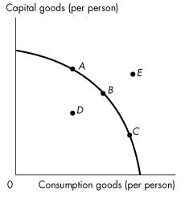
Figure 2.1.4

60) Refer to the production possibilities frontier in Figure 2.1.4. Which point is unattainable?
A) a.
B) b.
C) c.
D) d.
E) e.
Answer: E
Diff: 1
Topic: Production Possibilities and Opportunity Cost
Use the figure below to answer the following question.
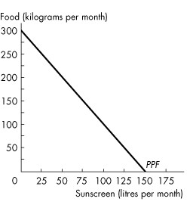
Figure 2.1.5

61) The graph in Figure 2.1.5 shows Yucatan's PPF for food and sunscreen. Yucatan faces ________ opportunity cost of food and ________ opportunity of sunscreen, which can be seen by the shape of the PPF.
A) an increasing; a decreasing
B) a constant; a constant
C) a decreasing; an increasing
D) an increasing; an increasing
E) a decreasing; a decreasing
Answer: B
Topic: Production Possibilities and Opportunity Cost
Source: MyEconLab
Use the figure below to answer the following question.
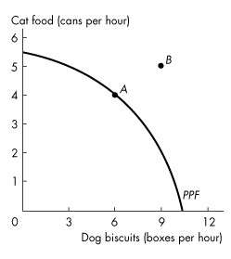
Figure 2.1.6

62) Figure 2.1.6 shows the production possibilities frontier for a firm that produces pet food. Point A is ________ and point B is ________. This PPF ________ illustrate scarcity because ________.
A) unattainable; attainable; does; because the firm cannot attain the points outside the frontier
B) attainable; unattainable; does not; the firm can produce any quantity it wants if it is willing to pay a high enough price
C) unattainable; attainable; does not; the firm can produce any quantity it wants if it is willing to pay a high enough price
D) attainable; unattainable; does; the firm cannot produce points outside the frontier and as the firm moves along the PPF, it cannot produce more dog biscuits without producing less cat food
E) attainable; unattainable; does not; it is downward sloping
Answer: D
Topic: Production Possibilities and Opportunity Cost
Source: MyEconLab

2.2 Using Resources Efficiently

1) Complete the following sentence. Marginal cost
A) is the opportunity cost of producing one more unit of a good or service.
B) is unrelated to the production possibilities frontier.
C) always equals marginal benefit.
D) remains constant.
E) is always greater then marginal benefit.
Answer: A
Diff: 1
Topic: Using Resources Efficiently
2) The quantity of shoes produced is measured along the x-axis of a bowed outward production possibilities frontier and the quantity of shirts produced is measured along the y-axis. As you move down towards the right along the production possibilities frontier, the marginal cost of
A) a pair of shoes decreases.
B) a pair of shoes increases.
C) a shirt decreases.
D) a shirt increases.
E) a pair of shoes and a shirt is equal at the midpoint between the x-axis and the y-axis.
Answer: B
Diff: 2
Topic: Using Resources Efficiently

3) Which of the following is true regarding marginal benefit?
I. The marginal benefit curve shows the benefit firms receive by producing another
unit of a good.
II. Marginal benefit increases as more and more of a good is consumed.
III. Marginal benefit is the maximum amount a person is willing to pay to
obtain one more unit of a good.
A) I only.
B) I and II.
C) I and III.
D) III only.
E) I, II, and III.
Answer: D
Diff: 3
Topic: Using Resources Efficiently

4) To describe preferences, economists use the concept of
A) opportunity cost.
B) scarcity.
C) marginal benefit.
D) marginal cost.
E) none of the above.
Answer: C
Diff: 1
Topic: Using Resources Efficiently

5) Complete the following sentence. As you consume more and more of a good,
A) marginal benefit increases.
B) marginal benefit decreases.
C) marginal benefit always equals marginal cost.
D) marginal benefit increases or decreases depending on where you are on the production possibilities frontier.
E) the price of the good falls.
Answer: B
Diff: 1
Topic: Using Resources Efficiently
6) The marginal benefit curve for a good
A) shows the benefit a firm receives from producing one more unit of that good.
B) shows the most a consumer is willing to pay for one more unit of that good.
C) is upward-sloping.
D) is bowed outward.
E) none of the above.
Answer: B
Diff: 1
Topic: Using Resources Efficiently
Source: Study Guide

Use the figure below to answer the following questions.

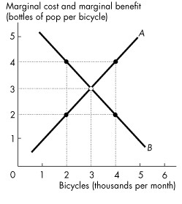
Figure 2.2.1

7) In Figure 2.2.1, the curve labeled B shows
A) the bottles of pop that people are willing to forgo to get another bicycle.
B) the bicycles that people are willing to forgo to get another bottle of pop.
C) the bottles of pop that people must forgo to get another bicycle.
D) that the benefits of producing more bicycles is greater than the benefits of producing more pop.
E) that the benefits of producing more pop is greater than the benefits of producing more bicycles.
Answer: A
Diff: 1
Topic: Using Resources Efficiently
8) In Figure 2.2.1, when 2,000 bicycles are produced each month
A) the marginal benefit from another bicycle is greater than the marginal cost of another bicycle.
B) more bicycles must be produced to reach the efficient level of output.
C) fewer bicycles must be produced to reach the efficient level of output.
D) the economy is efficient at this level of production of bicycles.
E) both A and B.
Answer: E
Diff: 2
Topic: Using Resources Efficiently

9) In Figure 2.2.1, the curve labelled A is the ________ curve and the curve labelled B is the ________ curve.
A) marginal cost; marginal benefit
B) marginal cost; trade
C) marginal benefit; trade
D) production possibilities; trade
E) marginal benefit; marginal cost
Answer: A
Diff: 1
Topic: Using Resources Efficiently

10) In Figure 2.2.1, when 4,000 bicycles are produced each month
A) the marginal benefit from another bicycle is greater than the marginal cost of another bicycle.
B) more bicycles must be produced to reach the efficient level of output.
C) fewer bicycles must be produced to reach the efficient level of output.
D) the economy is very efficient at this level of production of bicycles.
E) both A and B.
Answer: C
Diff: 2
Topic: Using Resources Efficiently

11) A marginal benefit curve measures
A) comparative advantage.
B) willingness to pay.
C) absolute advantage.
D) opportunity cost.
E) expenditure.
Answer: B
Diff: 1
Topic: Using Resources Efficiently
12) Allocative efficiency refers to a situation where
A) opportunity costs are equal.
B) we cannot produce more of any one good without giving up some other good.
C) goods and services are produced at the lowest possible cost and in the quantities that provide the greatest possible benefit.
D) opportunity cost is zero.
E) none of the above.
Answer: C
Diff: 1
Topic: Using Resources Efficiently

13) As production of food increases, marginal benefit from food
A) increases and marginal cost increases.
B) increases and marginal cost decreases.
C) decreases and marginal cost increases.
D) decreases and marginal cost decreases.
E) decreases and marginal cost is zero.
Answer: C
Diff: 1
Topic: Using Resources Efficiently
Source: Study Guide

14) Suppose the production possibilities frontier for skirts and pants is a straight line. As the production of skirts increases, the marginal benefit of skirts
A) increases and marginal cost is constant.
B) is constant and marginal cost decreases.
C) decreases and marginal cost increases.
D) decreases and marginal cost decreases.
E) decreases and marginal cost is constant.
Answer: E
Diff: 1
Topic: Using Resources Efficiently
Source: Study Guide

15) With allocative efficiency, for each good produced,
A) marginal benefit equals marginal cost.
B) marginal benefit is at its maximum.
C) marginal benefit exceeds marginal cost by as much as possible.
D) marginal cost exceeds marginal benefit by as much as possible.
E) marginal cost is at its minimum.
Answer: A
Diff: 1
Topic: Using Resources Efficiently
Source: Study Guide
16) Marginal benefit from a good or service is the benefit received from consuming ________. It is measured by the most that people are willing to pay for ________.
A) goods that you prefer; an additional unit of it
B) goods that you prefer; more of it
C) one more unit of it; an additional unit of it
D) one more unit of it; more of it
E) as much as is available; the total amount consumed
Answer: C
Topic: Using Resources Efficiently
Source: MyEconLab

Use the table below to answer the following questions.

Table 2.2.1

Ethanol  (barrels per day) |  | Food crops  (tonnes per day)
70 | and | 0
64 | and | 1
54 | and | 2
40 | and | 3
22 | and | 4
0 | and | 5

17) Refer to Table 2.2.1. Marginal benefit from food crops
A) equals the marginal cost of food crops.
B) remains constant as the quantity of food crops increases from 1 tonne a day to 2 tonnes a day.
C) cannot be calculated from the table.
D) increases as the quantity of food crops increases from 1 tonne a day to 2 tonnes a day.
E) equals 70 barrels of ethanol.
Answer: C
Topic: Using Resources Efficiently
Source: MyEconLab

2.3 Economic Growth

1) A technological improvement is represented by
A) an outward shift of the production possibilities frontier.
B) a movement along the production possibilities frontier.
C) a point inside the production possibilities frontier.
D) a point outside the production possibilities frontier.
E) a movement from a point inside the production possibilities frontier to a point on the production possibilities frontier.
Answer: A
Diff: 1
Topic: Economic Growth
2) In general, if country A is accumulating capital at a faster rate than country B, then country A
A) will soon have a comparative advantage in the production of most goods.
B) is using a larger proportion of resources to produce consumption goods.
C) will have a production possibilities frontier that is shifting out faster than country B's.
D) will have a higher rate of inflation than country B.
E) will have more unemployment than country B.
Answer: C
Diff: 2
Topic: Economic Growth

3) The principal reason that production possibilities have grown more rapidly in Hong Kong than in Canada over the last 40 years is because
A) of cheap Hong Kong labour.
B) of foreign aid to Hong Kong.
C) Hong Kong has fewer workers.
D) Hong Kong has more natural resources.
E) Hong Kong has devoted a larger proportion of its resources to capital accumulation.
Answer: E
Diff: 2
Topic: Economic Growth

4) Which one of the following would cause a production possibilities frontier to shift outward?
A) An increase in the stock of capital.
B) An increase in the production of consumption goods.
C) Bad weather.
D) A decision to fully utilize unemployed resources.
E) A decrease in the population.
Answer: A
Diff: 1
Topic: Economic Growth

5) The development of new goods and better ways of producing goods and services is
A) capital accumulation.
B) technological change.
C) the big tradeoff.
D) allocative efficiency.
E) none of the above.
Answer: B
Diff: 1
Topic: Economic Growth

6) The growth of capital resources, including human capital is
A) technological change.
B) capital accumulation.
C) depreciation.
D) opportunity cost.
E) none of the above.
Answer: B
Diff: 1
Topic: Economic Growth
7) Which one of the following would likely shift a production possibilities frontier inward?
A) Technological change.
B) A drought.
C) A decrease in the price of natural resources.
D) All of the above
E) None of the above, because production possibility frontiers do not shift inward.
Answer: B
Diff: 2
Topic: Economic Growth

Use the figure below to answer the following questions.

Figure 2.3.1

8) Refer to the production possibilities frontier in Figure 2.3.1. The production possibilities frontier will shift rightward most rapidly if current production is at
A) A.
B) B.
C) C.
D) D.
E) E.
Answer: A
Diff: 2
Topic: Economic Growth

9) A production possibilities frontier will shift outward FOR ALL OF THE FOLLOWING REASONS EXCEPT
A) a technological improvement.
B) an increase in the stock of capital.
C) an increase in the labour force.
D) opportunity cost is increasing.
E) none of the above.
Answer: D
Diff: 1
Topic: Economic Growth
10) A movement along the production possibilities frontier will result from
A) technological change.
B) change in the stock of capital.
C) change in the labour force.
D) all of the above.
E) none of the above.
Answer: E
Diff: 1
Topic: Economic Growth
Source: Study Guide

11) The opportunity cost of pushing the production possibilities frontier outward is
A) capital accumulation.
B) technological change.
C) reduced current consumption.
D) the gain in future consumption.
E) all of the above.
Answer: C
Diff: 2
Topic: Economic Growth
Source: Study Guide

12) In general, the higher the proportion of resources devoted to technological research in an economy, the
A) greater will be current consumption.
B) faster the production possibilities frontier will shift outward.
C) faster the production possibilities frontier will shift inward.
D) closer it will come to having a comparative advantage in the production of all goods.
E) more bowed out will be the shape of the production possibilities frontier.
Answer: B
Diff: 2
Topic: Economic Growth
Source: Study Guide

13) Consider a country that has two industries. In the north, they grow wild rice, which requires a lot of rainfall. In the south, they grow wheat, which requires just a moderate amount of rainfall (too much rainfall is bad for wheat production). One year, there is a record rainfall. This will result in
A) a parallel shift inward of the production possibilities frontier.
B) a parallel shift outward of the production possibilities frontier.
C) the production possibilities frontier swiveling, with the wild rice intercept increasing, and the wheat intercept decreasing.
D) the production possibilities frontier swiveling, with the wild rice intercept decreasing, and the wheat intercept increasing.
E) none of the above.
Answer: C
Diff: 3
Topic: Economic Growth
14) Suppose a hurricane causes extensive devastation, destroying houses, roads, schools and factories. What would be the effect of this hurricane on a production possibilities frontier consisting of consumption goods and capital goods?
A) It would shift outward at all points.
B) It would shift inward at all points.
C) There would be a movement along the existing production possibilities frontier towards a less capital-intensive point.
D) There would be a movement along the existing production possibilities frontier towards a more capital-intensive point.
E) There would be a movement from the existing production possibilities frontier inwards towards a point with unused or misallocated resources.
Answer: B
Diff: 2
Topic: Economic Growth

15) The depletion of fish stocks in Eastern Canada, with its accompanying unemployment, will lead to a
A) movement from the existing production possibilities frontier to a point inside the production possibilities frontier.
B) shift inward of the existing production possibilities frontier.
C) shift outward of the existing production possibilities frontier.
D) movement along the existing production possibilities frontier to a point of less fish production.
E) shift inward of the existing production possibilities frontier plus a movement to a point inside the new production possibilities frontier.
Answer: E
Diff: 3
Topic: Economic Growth

16) Which of the following quotations illustrates economic growth?
A) "The firm should lower the price it charges for widgets and gadgets."
B) "The firm should sell more gadgets, even if it means less widget sales."
C) "The more and more gadgets the firm produces, the bigger the fall in widget production."
D) "If the firm invests more in capital equipment, it can expand production next year."
E) "The firm has been able to lower costs due to its extensive experience in building widgets."
Answer: D
Diff: 2
Topic: Economic Growth

17) Economic growth ________ overcome scarcity because ________.
A) does; with economic growth the PPF rotates outward and eventually becomes a horizontal line
B) does; we will eventually reach the point where we have too much
C) does not; we can produce more goods and services but it is still impossible to satisfy all our wants
D) does not; economic growth requires capital accumulation and technological change
E) does; with economic growth the PPF rotates outward and eventually becomes a vertical line
Answer: C
Topic: Economic Growth
Source: MyEconLab
18) In 1968, the production possibilities per person in Canada were ________ than those in Hong Kong. Canada devoted ________ of its resources to accumulating capital and the remainder to consumption. Hong Kong devoted ________ of its resources to accumulating capital and the remainder to consumption. Because Hong Kong devoted a ________ fraction of its resources to accumulating capital, its production possibilities have ________.
A) smaller; one-fifth; one-third; greater; expanded more quickly
B) smaller; one-third; one-fifth; smaller; not expanded as quickly
C) greater; one-third; one-fifth; smaller; not expanded as quickly
D) greater; one-fifth; one-third; greater; expanded more quickly
E) greater; one-half; one-quarter; smaller; not expanded as quickly
Answer: D
Topic: Economic Growth
Source: MyEconLab

2.4 Gains from Trade

1) Individuals A and B can both produce good X. We say that A has a comparative advantage in the production of good X if
A) A has a lower opportunity cost of producing X than B.
B) A has a higher opportunity cost of producing X than B.
C) A can produce more units of X in a given time period than B.
D) A can produce X using newer technology than B.
E) A can produce less units of X in a given time period than B.
Answer: A
Diff: 3
Topic: Gains from Trade

2) Individuals A and B can both produce goods X and Y. Individual A has a comparative advantage in the production of X if
A) A is faster than B at producing X.
B) the amount by which A must reduce production of Y is less than the amount by which B must reduce production of Y to produce an additional unit of X.
C) B has superior knowledge about how to produce X.
D) A has a preference to consume X.
E) the amount by which A must reduce production of Y is more than the amount by which B must reduce production of Y to produce an additional unit of X.
Answer: B
Diff: 2
Topic: Gains from Trade

3) Debra has an absolute advantage in producing a good when she
A) has a comparative advantage in producing that good.
B) can produce the good at lower opportunity cost than anyone else.
C) can produce more of that good than anyone else, using the same quantity of inputs.
D) has exclusive rights to sell that good.
E) has better technology than anyone else.
Answer: C
Diff: 2
Topic: Gains from Trade
4) A person who has an absolute advantage in the production of all goods will
A) also have a comparative advantage in the production of all goods.
B) not be able to gain from specialization and trade.
C) produce all goods at the lowest opportunity cost.
D) not have a comparative advantage in the production of any goods.
E) have a comparative advantage in the production of only some goods and not others.
Answer: E
Diff: 2
Topic: Gains from Trade

Use the information below to answer the following questions.

Fact 2.4.1

In an eight-hour day, Andy can produce either 24 loaves of bread or 8 kilograms of butter. In an eight-hour day, Rolfe can produce either 8 loaves of bread or 8 kilograms of butter.

5) Given Fact 2.4.1, the opportunity cost of producing 1 loaf of bread is
A) 20 minutes (1/3 hour) for Andy and 1 hour for Rolfe.
B) 1/3 kilogram of butter for Andy and 1 kilogram of butter for Rolfe.
C) 3 kilograms of butter for Andy and 1 kilogram of butter for Rolfe.
D) 8 kilograms of butter for both Andy and Rolfe.
E) not calculable from the given information.
Answer: B
Diff: 2
Topic: Gains from Trade

6) From Fact 2.4.1, we know that
A) Andy has the lower opportunity cost of producing bread, while Andy and Rolfe have equal opportunity costs of producing butter.
B) Andy has the lower opportunity cost of producing both bread and butter.
C) Andy has the lower opportunity cost of producing bread, while Rolfe has the lower opportunity cost of producing butter.
D) Andy has the lower opportunity cost of producing butter, while Rolfe has the lower opportunity cost of producing bread.
E) Andy has the higher opportunity cost of producing both bread and butter.
Answer: C
Diff: 3
Topic: Gains from Trade

7) Refer to Fact 2.4.1. Which one of the following statements is true?
A) Andy has an absolute advantage in butter production.
B) Rolfe has an absolute advantage in butter production.
C) Andy has a comparative advantage in bread production.
D) Andy has a comparative advantage in butter production.
E) Rolfe has a comparative advantage in bread production.
Answer: C
Diff: 3
Topic: Gains from Trade
8) Refer to Fact 2.4.1. The opportunity cost of producing 1 kilogram of butter is
A) 20 minutes (1/3 hour) for Andy and 1 hour for Rolfe.
B) 1 hour for Andy and 1 hour for Rolfe.
C) 3 loaves of bread for Andy and 1/3 loaf of bread for Rolfe.
D) 3 loaves of bread for Andy and 1 loaf of bread for Rolfe.
E) 8 loaves of bread for Rolfe and 24 loaves of bread for Andy.
Answer: D
Diff: 2
Topic: Gains from Trade

9) Given Fact 2.4.1, Andy and Rolfe
A) can gain from trade if Andy specializes in butter production and Rolfe specializes in bread production.
B) can gain from trade if Andy specializes in bread production and Rolfe specializes in butter production.
C) cannot gain from trade.
D) can trade, but only Rolfe will gain.
E) can trade, but only Andy will gain.
Answer: B
Diff: 3
Topic: Gains from Trade
Source: Study Guide

10) Consider Fact 2.4.1. After specialization, total consumption will
A) depend on the preferences of Andy and Rolfe.
B) be 8 loaves of bread and 24 kilograms of butter.
C) be 32 loaves of bread and 16 kilograms of butter.
D) be 8 loaves of bread and 8 kilograms of butter.
E) be 24 loaves of bread and 8 kilograms of butter.
Answer: E
Diff: 2
Topic: Gains from Trade

Use the information below to answer the following questions.

Fact 2.4.2

Agnes can produce either 1 unit of X or 1 unit of Y in an hour, while Brenda can produce either 2 units of X or 4 units of Y in an hour.

11) Refer to Fact 2.4.2. Which one of the following statements is true?
A) Brenda has an absolute advantage over Agnes in the production of both goods.
B) Agnes has a comparative advantage in the production of Y.
C) Brenda has a comparative advantage in the production of X.
D) Brenda will not gain from trade.
E) Agnes will not gain from trade.
Answer: A
Diff: 3
Topic: Gains from Trade
12) Given Fact 2.4.2, the opportunity cost of producing a unit of X is
A) 1 unit of Y for Agnes and 2 units of Y for Brenda.
B) 1 unit of Y for Agnes and 1/2 unit of Y for Brenda.
C) 1 hour for Agnes and 1/2 hour for Brenda.
D) 1 hour for Agnes and 2 hours for Brenda.
E) 1 hour for Agnes and 1/4 hour for Brenda.
Answer: A
Diff: 2
Topic: Gains from Trade

13) Given Fact 2.4.2, the opportunity cost of producing a unit of Y is
A) 1 unit of Y for Agnes and 2 units of Y for Brenda.
B) 1 unit of Y for Agnes and 1/2 unit of Y for Brenda.
C) 1 hour for Agnes and 1/2 hour for Brenda.
D) 1 hour for Agnes and 2 hours for Brenda.
E) 1 unit of X for Agnes and 1/2 unit of X for Brenda.
Answer: E
Diff: 2
Topic: Gains from Trade

14) Complete the following sentence. Given Fact 2.4.2,
A) there will be gains from trade, no matter what Brenda and Agnes specialize in, as long as they specialize.
B) there will be gains from trade only if Agnes specializes in the production of Y and Brenda in X.
C) there will be gains from trade only if Agnes becomes faster at producing X.
D) there will be no gains from trade because Agnes has an absolute advantage.
E) there will be gains from trade if Agnes specializes in the production of X and Brenda in Y.
Answer: E
Diff: 2
Topic: Gains from Trade

15) Given Fact 2.4.2, what would be the total output of X and Y in an eight-hour day if Agnes and Brenda each specialized in producing the good in which they have a comparative advantage?
A) 3 units of X and 5 units of Y
B) 8 units of X and 16 units of Y
C) 8 units of X and 32 units of Y
D) 24 units of X and 40 units of Y
E) 16 units of X and 8 units of Y
Answer: C
Diff: 3
Topic: Gains from Trade
16) Any two individuals will gain from exchange
A) unless one has an absolute advantage in producing all goods.
B) if each specializes in the production of the good for which he has the higher opportunity cost.
C) unless they have the same opportunity costs for producing all goods.
D) unless they have different opportunity costs for producing all goods.
E) unless they have the same absolute advantage in producing all goods.
Answer: C
Diff: 3
Topic: Gains from Trade

Use the figure below to answer the following questions.

Table 2.4.1
The planets of Vulcan and Romulus each produce goods X and Y.
The following table gives points on their production possibilities frontiers.

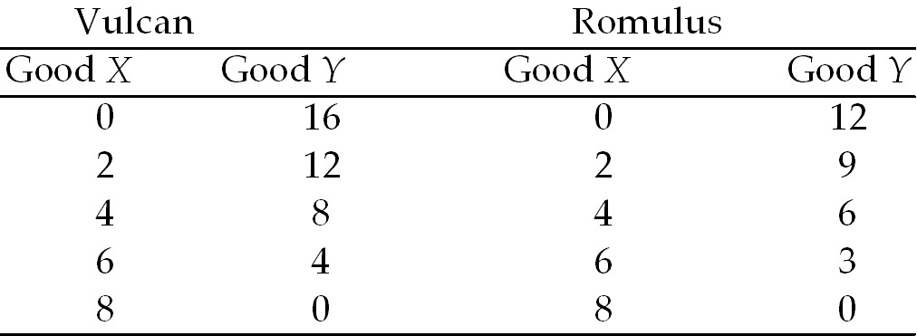

17) Refer to Table 2.4.1. Which one of the following is true?
A) Romulus has both an absolute advantage and a comparative advantage in the production of Y.
B) Romulus has both an absolute advantage and a comparative advantage in the production of X.
C) Vulcan has a comparative advantage in the production of X.
D) Romulus has a comparative advantage in the production of X.
E) Vulcan should specialize in the production of X.
Answer: D
Diff: 3
Topic: Gains from Trade

18) Refer to Table 2.4.1. Which one of the following is true?
A) The opportunity cost of producing more of good X is the same for both planets.
B) The opportunity cost of producing more of good Y is the same for both planets.
C) The opportunity cost of producing more of good X is lower in Vulcan.
D) The opportunity cost of producing more of good Y is lower in Vulcan.
E) Vulcans are smarter than Romulans.
Answer: D
Diff: 3
Topic: Gains from Trade
19) Refer to Table 2.4.1. For Vulcan, the opportunity cost of producing an additional unit of X is
A) 4 units of Y.
B) 2 units of Y.
C) 2/3 units of Y.
D) 1 unit of Y.
E) dependent upon how many units of X are already produced.
Answer: B
Diff: 2
Topic: Gains from Trade

20) Refer to Table 2.4.1. For Romulus, the opportunity cost of producing an additional unit of X is
A) 4 units of Y.
B) 2 units of Y.
C) 2/3 units of Y.
D) 1 unit of Y.
E) 3/2 units of Y.
Answer: E
Diff: 2
Topic: Gains from Trade

21) Refer to Table 2.4.1. For Romulus, the opportunity cost of producing an additional unit of Y is
A) 2/3 units of X.
B) 1/2 unit of X.
C) 2 units of X.
D) 3 units of X.
E) 3/2 units of Y.
Answer: A
Diff: 2
Topic: Gains from Trade

22) Refer to Table 2.4.1. For Vulcan, the opportunity cost of producing an additional unit of Y is
A) 2/3 units of X.
B) 1/2 units of X.
C) 2 units of X.
D) 3 units of X.
E) 4 units of X.
Answer: B
Diff: 2
Topic: Gains from Trade

23) Refer to Table 2.4.1. Each country will gain from trade if
A) Romulus specializes in both goods.
B) Vulcan specializes in both goods.
C) they both continue to produce both goods.
D) Vulcan specializes in good X and Romulus specializes in good Y .
E) Romulus specializes in good X and Vulcan specializes in good Y.
Answer: E
Diff: 3
Topic: Gains from Trade
24) If individuals A and B can both produce only goods X and Y and A does not have a comparative advantage in the production of either X or Y, then we know
A) B has an absolute advantage in the production of X and Y.
B) A and B have the same opportunity costs for X and for Y.
C) B has a comparative advantage in the production of both X and Y.
D) the gains from trade will be large but only in one direction.
E) A must have lower opportunity costs of production for both goods.
Answer: B
Diff: 3
Topic: Gains from Trade

25) Consider the following household. In 5 hours, Bob can cook 5 meals or clean 6 rooms. In 5 hours, Mary can cook 30 meals or clean 10 rooms. Select the best statement.
A) Bob has an absolute advantage in the production of both goods.
B) Since Mary is better at producing both goods, she should produce both.
C) Bob has a comparative advantage in cooking.
D) Mary should specialize in cooking.
E) none of the above
Answer: D
Diff: 3
Topic: Gains from Trade

Use the table below to answer the following questions.

Table 2.4.2
Production for one week by Sheila and Bruce

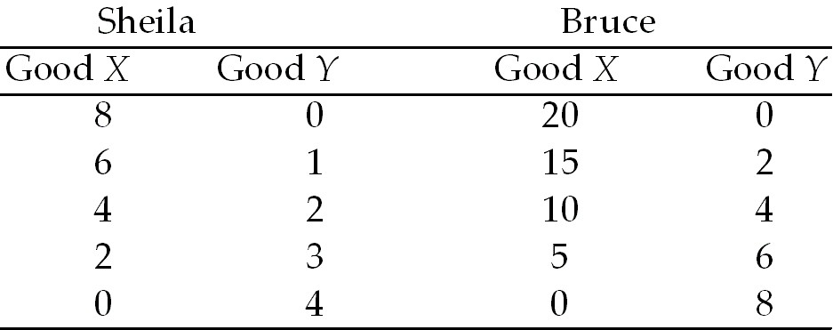

26) Given the information in Table 2.4.2, can Sheila and Bruce gain by specialization?
A) Yes, but only if Bruce gets paid more than Sheila.
B) No, not under the given circumstances.
C) It depends on the wages each earns .
D) Only if they are married to each other.
E) Yes, if each specializes in the good in which he has a comparative advantage.
Answer: E
Diff: 2
Topic: Gains from Trade
27) Given the information in Table 2.4.2, which one of the following is true?
A) Sheila should specialize in good X.
B) Bruce should specialize in good X.
C) The opportunity cost to Bruce of an additional unit of X is 0.4 units of Y.
D) A and B.
E) B and C.
Answer: E
Diff: 3
Topic: Gains from Trade

28) Suppose John and Joe each have different production possibility frontiers; John specializes in cloth and Joe specializes in corn. John's island unexpectedly has exceptionally good weather, and suddenly he is twice as productive in the production of both corn and cloth. Select the best statement.
A) This is an example of unemployed resources becoming employed.
B) As a result, John will have an absolute advantage in both corn and cloth.
C) As a result, it is possible that John and Joe will switch what they specialize in.
D) There will be no change in what John and Joe specialize in, because John's comparative advantage has not changed.
E) There will be a change in what John and Joe specialize in, because John's opportunity cost of production will have risen.
Answer: D
Diff: 3
Topic: Gains from Trade

29) It pays for people to specialize and trade with each other because
A) otherwise they would not survive.
B) they can take advantage of the fact they have an absolute advantage in the production of something.
C) otherwise they cannot take advantage of the fact they have a high opportunity cost of producing something.
D) this way they can consume outside their production possibilities frontier.
E) this way the strong can exploit the weak.
Answer: D
Diff: 2
Topic: Gains from Trade

30) There are two goods, X and Y. If the opportunity cost of producing good X is lower for Pam than for Gino, then
A) Pam has an absolute advantage in the production of X.
B) Gino has an absolute advantage in the production of Y.
C) Pam has a comparative advantage in the production of X.
D) Gino has a comparative advantage in the production of Y.
E) C and D.
Answer: E
Diff: 3
Topic: Gains from Trade
31) Mexico and Canada produce both oil and apples using labour only. A barrel of oil is produced with 4 hours of labour in Mexico and 8 hours of labour in Canada. A bushel of apples is produced with 8 hours of labour in Mexico and 12 hours of labour in Canada. Canada has
A) an absolute advantage in oil production.
B) an absolute advantage in apple production.
C) a comparative advantage in oil production.
D) a comparative advantage in apple production.
E) none of the above.
Answer: D
Diff: 3
Topic: Gains from Trade
Source: Study Guide

32) In Portugal, the opportunity cost of a bale of wool is 3 bottles of wine. In England, the opportunity cost of 1 bottle of wine is 3 bales of wool. Given this information,
A) England has an absolute advantage in wine production.
B) England has an absolute advantage in wool production.
C) Portugal has a comparative advantage in wine production.
D) Portugal has a comparative advantage in wool production.
E) no trade will occur.
Answer: C
Diff: 3
Topic: Gains from Trade
Source: Study Guide

33) Consider a world with two industries, lifeguarding and cleaning toilets. Data is exceptional at cleaning toilets because he has no sense of smell. On the other hand, he is very pale and sunburns easily, and therefore, is not suitable for lifeguard duties. Worf has an exceptionally keen sense of smell, trained during his years as a gourmet chef, that makes working as a toilet-cleaner difficult. On the other hand, he is dark, and the sun doesn't burn him–he is an exceptional lifeguard. In this case, we can say all of the following except
A) Worf has a comparative advantage at lifeguarding.
B) Data has a comparative advantage at toilet-cleaning.
C) Worf should specialize in lifeguarding.
D) Data should specialize in toilet-cleaning.
E) Worf has an absolute advantage in lifeguarding.
Answer: E
Diff: 3
Topic: Gains from Trade

34) Which of the following quotations illustrates dynamic comparative advantage?
A) "If the firm reorganized its production process, it could produce more widgets and more gadgets."
B) "The firm should sell more gadgets, even if it means less widget sales."
C) "The more and more gadgets the firm produces, the bigger the fall in widget production."
D) "If the firm invests more in capital equipment, it can expand sales next year."
E) "The firm has been able to lower costs due to its extensive experience in building widgets."
Answer: E
Diff: 2
Topic: Gains from Trade
35) Learning-by-doing is the basis of
A) absolute comparative advantage.
B) dynamic comparative advantage.
C) intellectual property rights.
D) financial property right.
E) none of the above.
Answer: B
Diff: 2
Topic: Gains from Trade
Source: Study Guide

36) To gain from comparative advantage, countries must not only trade, they must also
A) save.
B) invest.
C) engage in research and development.
D) engage in capital accumulation.
E) specialize.
Answer: E
Diff: 1
Topic: Gains from Trade
Source: Study Guide

37) In one hour, Sue can produce 50 caps or 10 jackets and Tessa can produce 70 caps or 7 jackets. Sue's opportunity cost of producing a cap is ________ jackets and Tessa's opportunity cost of producing a cap is ________ jackets.
________ has a comparative advantage in producing caps.
If Sue and Tessa each specialize in producing the good in which they have a comparative advantage and trade 1 jacket for 7 caps, ________.
A) 0.2; 0.10; Sue; Tessa gains but Sue loses
B) 5.0; 10.0; Tessa; Sue loses but Tessa gains
C) 5.0; 10.0; Sue; both Sue and Tessa gain
D) 0.2; 0.10; Tessa; both Sue and Tessa gain
E) 0.2; 0.10; Sue; both Sue and Tessa gain
Answer: D
Topic: Gains from Trade
Source: MyEconLab

2.5 Economic Coordination

1) Trade is organized using the social institutions of
A) firms.
B) property rights.
C) money.
D) markets.
E) all of the above.
Answer: E
Diff: 3
Topic: Economic Coordination
Source: Study Guide
2) Markets
I. enable buyers and sellers to get information
II. are defined by economists as geographical locations where trade occurs.
III. coordinate buying and selling decisions through price adjustments
Which of the above statements are correct?
A) I only
B) III only
C) I and III only
D) II and III only
E) I, II and III
Answer: C
Topic: Economic Coordination
Source: Study Guide

3) A property right is
A) any commodity or token that is generally acceptable as a means of payment.
B) an economic unit that hires factors of production and organizes those factors to produce and sell goods and services.
C) any arrangement that enables buyers and sellers to get information and to do business with each other.
D) a social arrangement that governs the ownership, use, and disposable of anything that people value.
E) a medium of exchange.
Answer: D
Topic: Economic Coordination
Source: MyEconLab

4) The flows in the market economy that go from firms to households are ________.
The flows in the market economy that go from households to firms are ________.
A) all flowing through goods markets; all flowing through factor markets
B) the real flows of goods and services and the income flows of wages, rent, interest and profits; the real flows of labour, land, capital and entrepreneurship and the flow of expenditure on goods and services
C) the income flows of wages, rent, interest, and profits and the flow of expenditure on goods and services; the real flows of goods and services and the real flows of labour, land, capital and entrepreneurship
D) the real flows of goods and services and the real flows of labour, land, capital and entrepreneurship; the income flows of wages, rent, interest, and profits and the flow of expenditure on goods and services
E) all flowing through factor markets; all flowing through goods markets
Answer: B
Topic: Economic Coordination
Source: MyEconLab
5) The main functions of markets include
A) promoting the social interest, but not the self-interest.
B) selling goods but not factors of production.
C) enabling buyers and sellers to get information about each other.
D) establishing a physical location for business transactions.
E) promoting the self-interest but not the social interest.
Answer: C
Topic: Economic Coordination
Source: MyEconLab

